Q1.

Code:

|  |
| --- |
| ***package Q1; import javax.swing.*; public class Q1 {  public static void main(String[] args) {  JFrame frame=new JFrame();  frame.setSize(800,600);  frame.setTitle("Welcome to Java");  frame.setVisible(true);   } }*** |

Output:

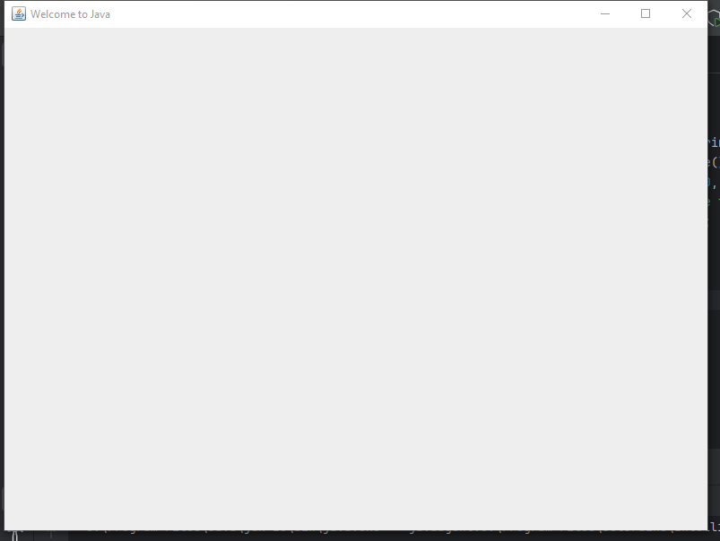

Q2.

Code:

|  |
| --- |
| ***package Q2; import javax.swing.*; import java.util.Scanner;  public class Q2 {  public static void main(String[] args) {  Scanner scanner=new Scanner(System.in);   System.out.println("Enter your first name:");  String firstname =scanner.next();  System.out.println("Enter your last name:");  String lastname=scanner.next();   System.out.println(firstname+" "+lastname);   JFrame frame=new JFrame();  frame.setSize(500,200);  frame.setTitle(firstname+" "+lastname);  frame.setVisible(true);  } }*** |

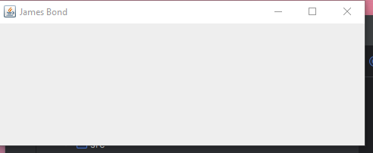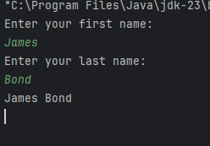



Q3.

Code:

|  |
| --- |
| ***package Q3;  import java.util.Scanner;  public class Q3 {  public static void main(String[] args) {  Scanner scanner=new Scanner(System.in);   System.out.println("Enter your first name:");  String firstName=scanner.next();  System.out.println("Enter your middle name:");  String middleName=scanner.next();  System.out.println("Enter your last name:");  String lastName=scanner.next();   System.out.println(firstName+" "+middleName.substring(0,1)+"."+lastName);    //Another method to display the middle name with first character.  // System.out.println(firstName+" "+middleName.charAt(0)+"."+lastName);  } }*** |

Output:

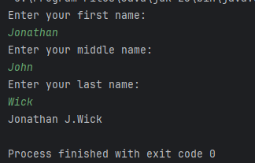

Q4.

Code:

|  |
| --- |
| ***package Q4;  import java.text.SimpleDateFormat; import java.util.Date;  public class Q4 {  public static void main(String[] args) {  Date today=new Date();  //System.out.println(today);   SimpleDateFormat sdf=new SimpleDateFormat("dd MMM yyyy");   System.out.println(sdf.format(today));  } }*** |

Output:

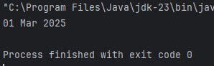

Q5

Code:

|  |
| --- |
| ***package Q5;  import java.text.SimpleDateFormat; import java.util.Date;  public class Q5 {  public static void main(String[] args) {  Date today=new Date();  SimpleDateFormat sdf=new SimpleDateFormat("EEEE,MMMM dd,yyyy");   System.out.println(sdf.format(today));  } }*** |

Output:

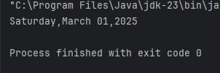

Q6

Code:

|  |
| --- |
| ***package Q6;  import javax.swing.*; import java.util.Scanner;  public class Q6 {  public static void main(String[] args) {  Scanner scanner=new Scanner(System.in);  JFrame frame=new JFrame();   System.out.println("Enter the width:");  int width=scanner.nextInt();   System.out.println("Enter the height:");  int height=scanner.nextInt();   System.out.println("Enter the title of the window:");  String title=scanner.next();   //JFrame frame=new JFrame(title); We create a JFrame window with the given title  frame.setSize(width,height);  frame.setTitle(title);  frame.setVisible(true);  } }*** |

Output:

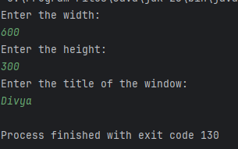

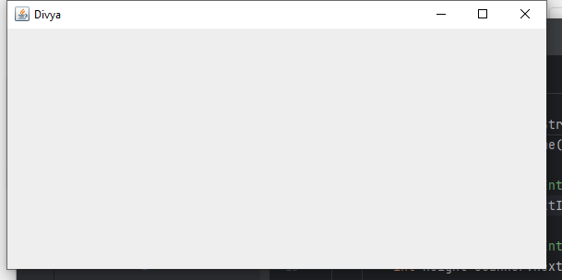

Q7

Code:

|  |
| --- |
| ***package Q7;  import javax.swing.*; import java.text.SimpleDateFormat; import java.util.Date;  public class Q7 {  public static void main(String[] args) {  Date today=new Date();  JFrame frame=new JFrame();   SimpleDateFormat sdf=new SimpleDateFormat("hh:mm:ss a");  String title=sdf.format(today);   frame.setSize(400,500);  frame.setTitle(title);  frame.setVisible(true);  } }*** |

Output:

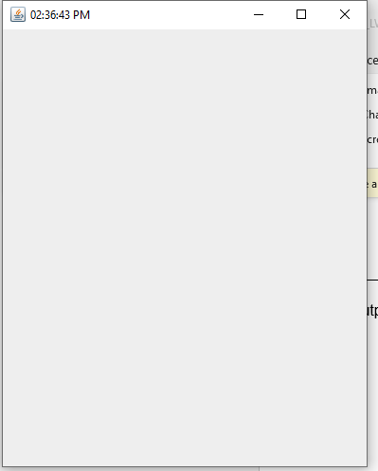

Q8

Code:

|  |
| --- |
| ***package Q8;  import java.util.Scanner;  public class Q8 {  public static void main(String[] args) {  Scanner scanner=new Scanner(System.in);  System.out.println("Enter the string that contain single exclamation mark:");  String input=scanner.nextLine();   String[] parts=input.split("!",2);  if(parts.length==2){  System.out.println(parts[0].trim());***  ***// trim removes leading and trailing spaces  System.out.println(parts[1].trim());  }else{  System.out.println("no '!; found in input");  }  } }*** |

Output:

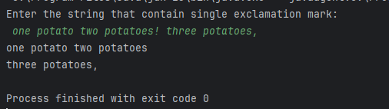

Q9

Code:

|  |
| --- |
| ***package Q9;  import java.util.Scanner;  public class Q9 {  public static void main(String[] args) {  Scanner scanner=new Scanner(System.in);   System.out.println("Enter a string:");  String input=scanner.nextLine();   System.out.println(input.length());  System.out.println(input.substring(0,1));  System.out.println(input.substring(input.length()-1));  //Extracts the last character from input.length()-1 to the end,we don't need to specify an end index.  } }*** |

Output:

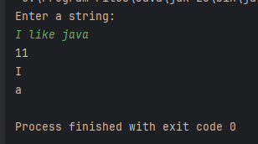

Q10

Code:

|  |
| --- |
| ***package Q10;  import java.util.Scanner;  public class Q10 {  public static void main(String[] args) {  Scanner scanner=new Scanner(System.in);  System.out.println("Enter a odd length word:");  String word=scanner.next();   if(word.length()%2==1){  System.out.println("Middle character:"+word.charAt(word.length()/2));  }else{  System.out.println("Error! Word length is not odd.");  }  } }*** |

Output:

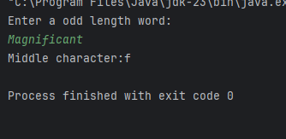

Q11

Code:

|  |
| --- |
| ***package Q11;  import java.util.Scanner;  public class Q11 {  public static void main(String[] args) {  Scanner scanner=new Scanner(System.in);  System.out.println("Enter your first name:");  String firstName=scanner.next();  System.out.println("Enter your middle name:");  String middleName=scanner.next();  System.out.println("Enter your last name:");  String lastName=scanner.next();   System.out.println(lastName+","+" "+firstName+" "+middleName.substring(0,1)+".");  } }*** |

Output:

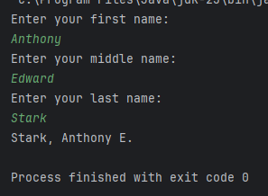

Q12

Code:

|  |
| --- |
| ***package Q12;  import javax.swing.*;  public class Q12 {  public static void main(String[] args) {  JFrame frame=new JFrame();  frame.setSize(300,200);  frame.setTitle("My First Frame");  frame.setLocation(50,100);  frame.setVisible(true);    } }*** |

Output:

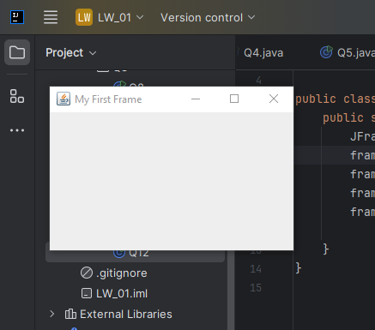

Q13

Code:

|  |
| --- |
| ***package Q13;  import javax.swing.*;  class Q13{  public static void main(String[] args) {  JFrame myWindow;  myWindow = new JFrame();  myWindow.setSize(500, 250);  myWindow.setTitle("UOK");  myWindow.setVisible(true);  try {Thread.sleep(500);} catch(Exception e) { }  myWindow.setVisible(false);  try {Thread.sleep(500);} catch(Exception e) { }  myWindow.setVisible(true);  } }*** |

Output:

